**Experiments -2 Design of Logo using GIMP.**

**Installation of GIMP:**

**Step 1:**Start a new graphic with 800×600 px dimensions, or whatever your preferences are.  
Choose the ellipse select tool and make a circular selection similar to mine. I made one of 220px in diameter.

[vultr banner](https://www.vultr.com/?ref=7224906)

|  |  |
| --- | --- |
| [First circle selection](http://www.armino.ro/wp-content/uploads/2009/09/g1_1_012.jpg)  First circle selection | **Note:**You can adjust your dimensions exactly by entering them manually in the tool options.  **[Enter ellipse selection manual size](http://www.armino.ro/wp-content/uploads/2009/09/g1_1_02.jpg)**  Enter ellipse selection manual size |

**Step 2:** Building the first ring  
Go to [Select] menu and choose [Border] by 8 px. This will be our outer circle.

[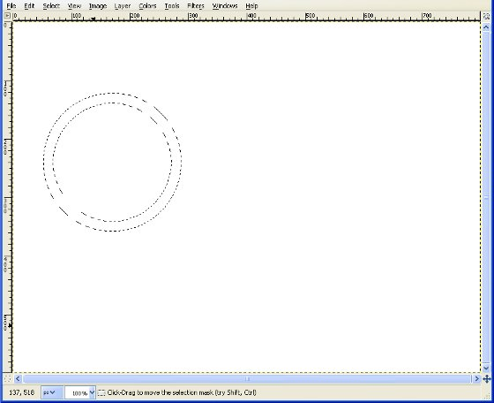](http://www.armino.ro/wp-content/uploads/2009/09/g1_2_011.jpg)

Border 8 px

Now create a new transparent layer above the background and keep the selection active.  Name the new layer “audi circle”.

[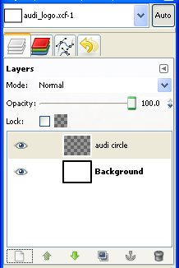](http://www.armino.ro/wp-content/uploads/2009/09/g1_2_021.jpg)

The audi circle layer

From the toolbox select the gradient tool (FG to BG) and fill the selection with a black to white linear gradient from bottom to the top as show in the next image. The “audi circle” layer must be the active layer.

[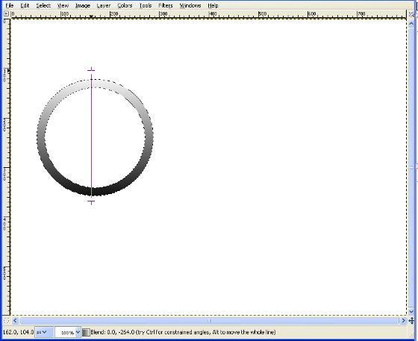](http://www.armino.ro/wp-content/uploads/2009/09/g1_2_031.jpg)

Outer circle gradient fill

Now we have to make the inner circle. From the toolbox choose [Fuzzy] select tool and click inside the circle.

[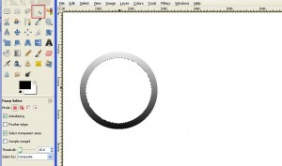](http://www.armino.ro/wp-content/uploads/2009/09/g1_2_041.jpg)

Inner circle - click on the picture to enlarge

Then go to [Select] menu, choose Shrink and type a value of 8 px.

[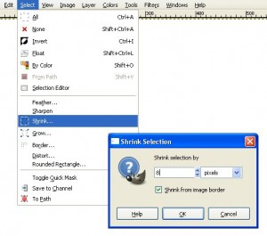](http://www.armino.ro/wp-content/uploads/2009/09/g1_2_05.jpg)

Shrink selection by 8px

Go again to [Select] menu, choose Border and type a value of 8px again. The workspace should look like this:

[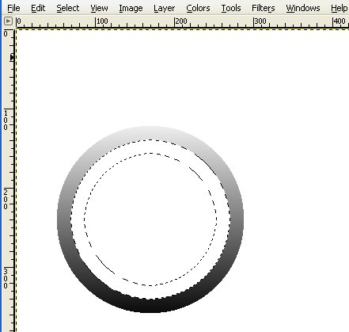](http://www.armino.ro/wp-content/uploads/2009/09/g1_2_06.jpg)

Inner circle - border

Now repeat the gradient fill as described above but from top to bottom. Remember that the “audi circle” layer must be the active layer.

[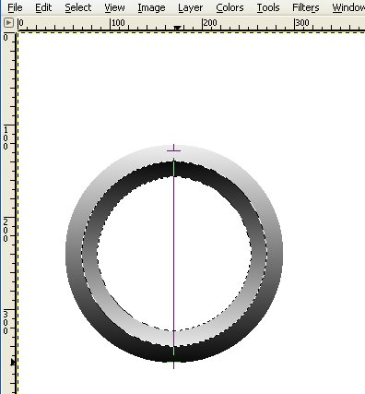](http://www.armino.ro/wp-content/uploads/2009/09/g1_2_07.jpg)

Inner circle gradient filled

As you can see our design starts to get a shape.

Step 3: Duplicate the rings  
Right click on the “audi layer” and choose “Alpha to selection”.

[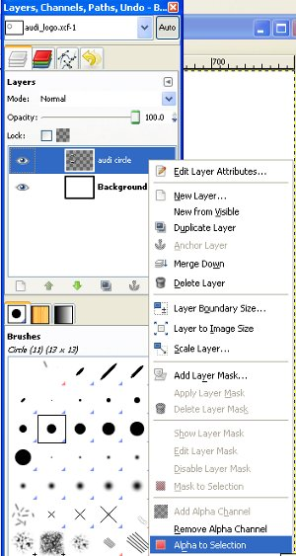](http://www.armino.ro/wp-content/uploads/2009/09/g1_3_01.jpg)

Alpha to selection

As you observe, the whole ring is selected. Now copy the selection with (CTRL+C) and paste it (CTRL+V).  
Now move your pasted graphic as in the next photo.

[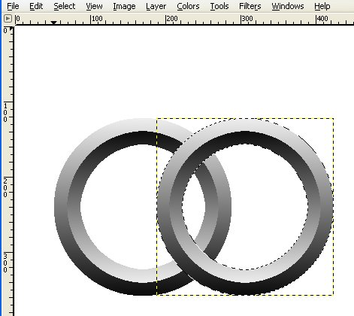](http://www.armino.ro/wp-content/uploads/2009/09/g1_3_02.jpg)

Duplicated ring

In order to move you drag with the mouse the pasted selection to the desired position. After you begin dragging press CTRL for axis constraint. This will ensure the alignment of the rings.  
Go to the layers toolbox and click on the [new layer] button.  
**Note:** I have added the pasted ring in a new layer in order to be able to correct it’s position easier.

[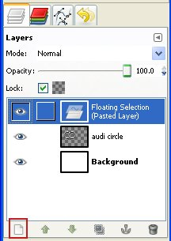](http://www.armino.ro/wp-content/uploads/2009/09/g1_3_03.jpg)

new layer

At this point your layers should look as below:

[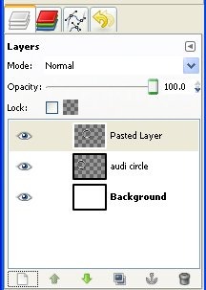](http://www.armino.ro/wp-content/uploads/2009/09/g1_3_04.jpg)

Layers 2 rings

Don’t bother to rename the “Pasted layer” as we will merge the layers together later. Now repeat the step above and create the rest of the rings.  
Until now we have something like this:

[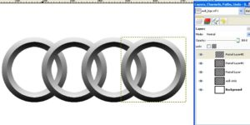](http://www.armino.ro/wp-content/uploads/2009/09/g1_3_051.jpg)

4 rings

We are not ready yet. We have to add some more magic to our logo. First we will combine all pasted layers into “audi circle” layer.  
Go to Layers toolbox, right click on the topmost layer and select “Merge Down” from the menu.

[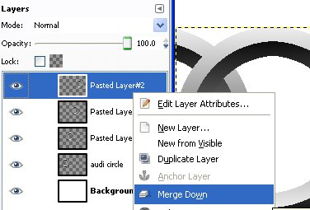](http://www.armino.ro/wp-content/uploads/2009/09/g1_4_01.jpg)

Merge down layers

**Step 4:**Final touch  
Duplicate the layer “audi circle” and move the duplicate below it. Also hide the “audi circle” layer by clicking on the eye icon.

[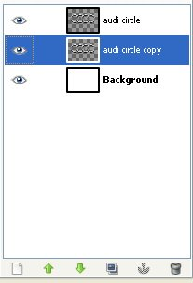](http://www.armino.ro/wp-content/uploads/2009/09/g1_4_02.jpg)

Audi circle copy

Right click the “audi circle copy” and select from the menu “Alpha to selection”. Now fill the selection with black.

[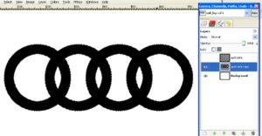](http://www.armino.ro/wp-content/uploads/2009/09/g1_4_03.jpg)

Duplicate layer black

Now deselect (SHIFT+CTRL+A) everything and go to the [Filters] menu -> [Blur] -> Gaussian blur.  
Select a value of 15px.

[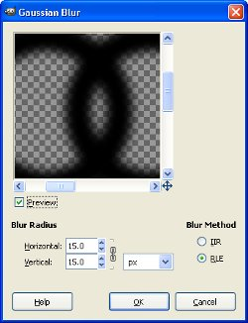](http://www.armino.ro/wp-content/uploads/2009/09/g1_4_04.jpg)

Gaussian blur

That’s it. We now have a nice and simple Audi logo. Don’t forget to unhide the “audi circle” layer if you haven’t done so already.

[](http://www.armino.ro/wp-content/uploads/2009/09/audi_logo.jpg)